**“E-Recruit: An Online Recruitment System**

**for Insurance and Investment Agency**

**in Mindoro”**

A non-thesis Project

Presented to the Faculty of the

College of Computer Studies

**MINDORO STATE UNIVERSITY**

Calapan City Campus

Masipit, Calapan City, Oriental Mindoro

In Partial Fulfillment

of the Requirements for the Course of

**APPLICATION DEVELOPMENT AND EMERGING TECHNOLOGY**

Caibal, Lester M.

Escalera, Jandel L.

Ramos, Jef

BSIT III-F1

October 2023

**TABLE OF CONTENTS**

|  |  |  |  |
| --- | --- | --- | --- |
| **Chapter 1. Introduction** | | |  |
|  | **Project Context ……………………………………………………………………………** | | **1** |
|  | **Objectives …………………………………………………………………………………………** | | **3** |
|  | **Scope and Limitations ……………………………………………………………** | | **5** |
|  | **Definition of Terms …………………………………………………………………** | | **5** |
| **Chapter 2. Requirements Specification** | | |  |
|  | **Hardware and Software Requirements …………………………** | | **8** |
|  | **Functional Requirements ………………………………………………………** | | **10** |
|  | **Non-Functional Requirements ……………………………………………** | | **14** |
|  |  | Operational Requirement **………………………………………** | **14** |
|  |  | Performance Requirement **………………………………………** | **15** |
|  |  | Security Requirement **………………………………………………** | **16** |

**CHAPTER 1. INTRODUCTION**

In this chapter, researcher will delve into the essential aspects of the project that provide a comprehensive foundation for the project ahead.

**Project Context**

Digital technology is continuously evolving and reshaping industries. It has a huge impact on society because it influences the way people access information, communicate, and how people move in this society. As technologies are further developed, these issues also give rise to significant ethics and privacy concerns that need to be addressed. This is important because it enables a lot of things such as organizing, saving, and manipulating data in ways that will make work more efficient and effective. Digital Technology would surely prove to be a common asset in all professions, given the speed of technological development today.

The researchers are proposing the Online Recruitment System for Insurance and Investment Agents in Mindoro. This system will help to facilitate the hiring process for Agent’s applicants, it will help to make it easier to obtain and provide information because their traditional method will be replaced by a paperless transaction or Management system.

Recruitment management allows organizations to efficiently and effectively manage candidate/employee information, streamline the recruiting process, attract more qualified applicants, and adapt to modern recruitment strategies. It helps organizations create a niche for themselves by procuring talents without overshooting their budget and ensures proper placement, which improves employee morale. Recruitment management systems provide a robust toolset for reviewing, selecting, and sharing applicant information, screening applicants, managing duplicate candidates, and tracking candidate information. It also helps organizations reach out to young talent through social media (Obipi & Kalio, 2018).

A Recruitment Management System is important because it streamlines the recruitment process, saves time and effort for the HR team, improves collaboration and communication among the hiring team, enables data-driven decision making, and enhances the candidate experience. It automates tasks such as job posting, resume screening, and candidate tracking, making the recruitment process more efficient and organized. It also provides a centralized platform for team members to access and review candidate information, share feedback, and make informed decisions. Additionally, it collects and analyzes data on recruitment metrics, helping HR professionals identify areas for improvement and make data-backed hiring strategies. Lastly, it improves the candidate experience by allowing easy application tracking and timely updates (Edirisinghe, 2020).

**Objectives**

The study aims to develop and design an online recruitment system for insurance and investment agents in Mindoro, that will help the employer and applicants of Mindoro to make their transactions faster and easier. The main objective of this study is to improve the overall recruitment experience and become more accurate and efficient.

Specifically, this study is intended to:

1. Implement an online platform for agent applications that accepts electronic forms and signatures.
2. Create a thorough internet recruitment plan to interact and connect with potential agents in far-off places
3. Improve the agent hiring process by giving applicants easy access to online resources and support.
4. Reduce the cost that is associated with the traditional ways in recruiting new employees.
5. Make the hiring process more efficient by having to look on the applicant’s background without even meeting them personally.
6. Having a more efficient way of screening and interview scheduling through online.
7. Use the system to gather information of applicants to and analyze for better decision making.
8. Improve the experience of the applicant by providing them a user-friendly platform when applying.
9. Make a database of potential candidates for future openings.
10. Ensure the system follows the data protection and recruitment regulations.

**Scope and Limitations**

This study is limited to the aspects and factors of creating, designing, and implementing an Online Recruitment System for Insurance and Investment Agents. The proposed system will accommodate the transactions in recruiting agents only in Mindoro, Philippines. There are three users in the system; the admin, agents, and the applicants. The admin can add or register applicants, as well as the admin can use the system in recruitment, and then the agents can only access the recruitment system, Lastly, the applicants can view the requirements and input information about his/her background information, as well as the applicants can enter and edit information through the online platform using the system.

**Definition of Terms**

To facilitate comprehension and enhance clarity, researcher break down and explain the following terms:

**Metrics** - is a quantifiable measure used to assess and analyze the performance and effectiveness of the Online Recruitment System.

**Niche** - is the specific skill set or job market focus of the Online Recruitment System.

**Digital Technology** - is the utilization of electronic devices, software, and online resources to facilitate, and enhance various processes within the Online Recruitment System.

**Recruitment System** - is an integrated set of processes, tools, and technologies designed to manage and optimize the end-to-end recruitment and hiring process. It typically includes functionalities for posting job vacancies, collecting applications, screening candidates, and managing the overall hiring workflow.

**Overshooting** - is the situation where the number of applicants exceeds the available positions.

Toolset - is a collection of software tools and applications integrated into the Online Recruitment System to perform various tasks such as applicant tracking and evaluation.

**Social Media** - is utilized for postings, employer branding, and reaching potential applicants through platforms like Twitter, and Facebook.

**Data-Backed Hiring** - relies on the analysis of data and metrics to make informed decisions throughout the hiring process.

**Online Platform** - is a web-based interface or application that facilitates various recruitment activities, including application submission, communication between agents and applicants, and the management of the hiring workflow.

**Electronic Forms** - is a digital document that replace traditional paper-based forms in the recruitment process.

**Database** - is structured collection of data stored electronically, candidate profiles, and other relevant details.

**CHAPTER 2. REQUIREMENTS SPECIFICATION**

This chapter elucidates the specific criteria, features, and functionalities essential for the successful realization of our project.

**Hardware and Software Requirements**

**Software Requirements**

|  |  |
| --- | --- |
| **Software used** | **Description** |
| Visual Studio Code | Visual Studio Code, ranging from version 1.70 to version 1.84, is a widely used and popular code editor. |
| CodeIgniter 4 | CodeIgniter 4, specifically version 4.4.1, stands as a PHP web application framework for efficient web development. |
| Firefox or Google Chrome | Firefox or Google Chrome, both recognized web browsers, provide users with diverse options for internet browsing. |
| Windows 10 and Windows 11 | Windows 10 through Windows 11 represents a progression of different versions within the Windows operating system, catering to evolving user needs and system requirements. |
| Laragon | Laragon version 6.0.0.0 is a Windows-based web development environment, streamlining the setup and management of web projects. |
| phpMyAdmin | phpMyAdmin, at version 5.2.1, serves as a web-based tool designed for the efficient management of MySQL databases. |

**Hardware Requirements**

|  |  |  |  |  |
| --- | --- | --- | --- | --- |
| **Hardware** | **Function** | **Specifications** | | **Unit** |
| **Minimum** | **Recommended** |
| CPU and Memory | Efficient handling of loads | At least 16GB RAM | At least 16GB RAM | GB |
| Storage | Faster data access | 256GB SSD | 512GB SSD | GB |
| Network Infrastructure | Reliable and high-speed internet connectivity | Integrated dedicated 4G LTE modem | Integrated dedicated 4G LTE modem | N/A |
| Laptop | Development workstation with connectivity | Intel Core i5 processor, 16GB DDR4 RAM, 256GB SSD, | Intel Core i5 processor, 16GB DDR4 RAM, 512GB SSD, | Varies (e.g., inches) |

**Functional Requirements**

|  |  |
| --- | --- |
| **ID NO** | **Requirement Description** |
| **FR1** | **Data Requirements** |
| **Administrator Account** | |
| **1.1** | The system should facilitate the administrator to create an account, log in using registered credentials, and change the password through a 'Forgot Password' option. |
| **1.2** | The system must provide a comprehensive dashboard for the administrator, visually presenting user activity, response times, error rates, and others. |
|  | The system should allow the administrator to view, manage, and access data for both agents and applicants, and add new agent accounts. |
| **1.3** | The system must implement a review process where the administrator can review the data submitted by applicants before confirming its transfer to the respective agent's dashboard. |
| **1.4** | The system should provide the administrator to display an overview of the total number of agents, applicants, and other relevant recruitment data. |
| **1.5** | The system must enable the administrator to manage their profile details, including personal information and account settings. |
| **1.6** | The system should allow the administrator to download applicant forms and other relevant documents as PDF files for record-keeping and offline access. |
| **1.7** | The system should have facilitated communication between the administrator, applicants, and agents through an integrated messaging system within the platform. |
| **1.8** | The system should have a notification system to alert the administrator of any new messages, incoming applicants, or other relevant system activities. |
| **1.9** | The system must provide the administrator with a robust search and filtering mechanism to locate specific information about agents and applicants quickly. |
| **Agent Account** | |
| **1.1** | The system should have a dedicated dashboard for the employees that displays the number of applicants they have recruited. This dashboard should include visually informative elements such as bar graphs or charts, illustrating recruitment metrics and performance data for easy interpretation and analysis. |
| **1.2** | The Agents/Employers must be able to log in using their given email and password by the administrator. |
| **1.3** | The system should have a facility where the agents and administrators could communicate, allowing agents to seek guidance and support when needed. |
| **1.4** | Agents should have the ability to securely view the data of applicants they have recruited, including personal information, application forms, and application status. |
| **1.5** | The system should enable the agents to send messages directly so their recruited applicants through an integrated messaging system within the platform. This feature should allow for real-time communication and seamless interaction between agents and their recruits. |
| **1.6** | The system should enable the agents to manage their account details, including profile information, changing of passwords, and other relevant settings. |
| **Applicants Account** | |
| **1.1** | The system should allow new applicants to create an account by providing necessary information like name, email address and password. |
| **1.2** | The applicants must be able to log in using their registered email and password. |
| **1.3** | The system must provide an online form for applicants to fill out personal and professional information, including contact details, work experience, education, and other relevant information. |
| **1.4** | The system should allow the applicant/s to upload the required documents and images such as resumes, identification, certificates, and other relevant files to support their application. |
| **1.5** | The Applicants should be able to browse and select a financial adviser from a list of available FAs. |
| **1.6** | The system should enable applicants to save their work and return to the application later for modifications or updates before submission. |
| **1.7** | The system must incorporate a messaging feature that permits applicants to communicate with the system administrator or assigned agents regarding their application or any related queries. |
| **1.8** | The system must provide a submission mechanism that allows applicants to formally submit their completed application to the system. |

**Non-Functional Requirements**

**Operational Requirement**

|  |  |
| --- | --- |
| **ID No.** | **Requirement Decription** |
| **1.1** | The system features an intuitive interface for applicants, catering to varying technical expertise levels, ensuring a seamless and user-friendly experience. |
| **1.2** | The system is compatible with desktops, laptops, tablets, and smartphones, ensuring applicants can access it on their preferred devices. |
| **1.3** | Robust error handling prevents incomplete or inaccurate submissions, maintaining data accuracy and application integrity. |
| **1.4** | The system is scalable to handle a large number of concurrent users during peak application periods without performance degradation. |
| **1.5** | Applicants can effortlessly upload relevant documents and images directly within the application process. |
| **1.6** | The system supports a user-friendly multi-step application process, allowing applicants to save progress and resume at their convenience. |
| **1.7** | The system adheres to data privacy regulations, ensuring secure handling of personal data throughout the application process. |
| **1.8** | Applicants have 24/7 access to the system, accommodating different time zones and enabling convenient submission at any time. |

**Performance Requirement**

|  |  |
| --- | --- |
| **ID No.** | **Requirement Decription** |
| **1.1** | The system must respond to user actions (e.g., form submissions, document uploads) within 5 seconds to ensure a seamless application process. |
| **1.2** | Application pages and forms should load within 3 seconds to provide a smooth user experience and minimize the risk of applicant frustration or abandonment. |
| **1.3** | The system must handle a minimum of 500 concurrent users without a performance drop, ensuring all applicants can access and use the system concurrently. |
| **1.4** | The system should maintain 99.9% uptime, allowing for a maximum of 30 minutes downtime per month for maintenance or updates, ensuring continuous accessibility. |
| **1.5** | The system should enable the upload of images and documents, supporting a file size of up to 5MB, to prevent delays during the application submission process. |
| **1.6** | The system should retrieve applicant data within 3 seconds, enabling recruitment administrators to promptly access and assess candidate profiles and qualifications. |

**Security Requirement**

|  |  |
| --- | --- |
| **ID No.** | **Requirement Decription** |
| **1.1** | Passwords are specifically encrypted using SHA-224 or SHA-256 from the SHA-2 family before storage in the directory, enhancing security and preventing unauthorized access. |
| **1.2** | The system strictly enforces role-based access control, ensuring that only designated personnel with specific roles can access and modify sensitive application data, minimizing the risk of unauthorized access. |
| **1.3** | Access to the database is meticulously controlled, with only authorized users granted specific permissions based on their roles. |
| **1.4** | Stored data in the database is encrypted, providing an additional layer of protection against unauthorized access and data breaches. |
| **1.5** | Routine security assessments are conducted to identify and address potential vulnerabilities, ensuring the ongoing integrity of the stored data. |
| **1.6** | The system performs regular and automated data backups, minimizing the risk of data loss and facilitating swift recovery in the event of system failures or cyber-attacks. |

**CHAPTER 3.**

**DESIGN AND DEVELOPMENT METHODOLOGIES**

In this chapter, researcher examin into the intricacies of design and development methodologies, exploring essential frameworks and approaches for effective project realization.

**System Design**

The system/project developers created a comprehensive plan to develop a system that is only exclusive for the applicants, agents, and administrators. The reason for this is that when they use their traditional way of recruiting and looking for possible applicants, they spend a lot of effort and money. Which makes it hard for them and it is also costly since they have to travel around to personally meet the applicants. This system will make it easy for the company and their agents when it comes to recruiting applicants. Agents will recruit possible applicants for their job openings. Using the system, they could just send a link on their applicants were they can just register and log-in their accounts, after that they’ll just have to fill-up some forms and send their documents virtually, it will be more cost efficient and less effort for both sides. They could also just check the applicants’ documents and choose from them. They could also just talk to them remotely or just sending them an email for updates.

**Database Design**

The design of the database that includes a lot of entities on the E-recruitment is an important part of the website development. This compiles the information of the applicants that they input on the forms.

This displays the tables along with a description, related data types, and the fields that were used. The process collected, arranged, and verified the meaning of designated data phrases. This further illustrates how the two things are related.

The MySQL RDBMS is used by the developers for database design. With MySQL, we can establish relationships between tables that must be connected to one another. The E-Recruit database will be designed.

|  |  |  |  |  |
| --- | --- | --- | --- | --- |
| **Field Name** | **Data Type** | **Size** | **Default** | **Description** |
| nonlife | varchar | 255 | Default Null | If nonlife |
| life | varchar | 255 | Default Null | If life |
| varlife | varchar | 255 | Default Null |  |
| accaAndHealth | varchar | 255 | Default Null |  |
| othercb | varchar | 255 | Default Null |  |
| othertb | varchar | 255 | Default Null |  |
| agencyname | varchar | 255 | Default Null | Agency Name |
| fname | varchar | 255 | Default Null | Applicant’s Name |
| nickname | varchar | 255 | Default Null | Applicant’s Nickname |
| birthdate | date |  | Current Time Stamp | Birth Date |
| placeOfBirth | varchar | 255 | Default Null | Applicant’s Place of Birth |
| gender | varchar | 10 | Default Null | Applicant’s Gender |
| bloodType | varchar | 5 | Default Null | Applicant’s Blood Type |
| homeAddress | varchar | 255 | Default Null | Applicant’s Home Address |
| mobileNo | varchar | 15 | Default Null | Applicant’s Mobile Number |
| landline | varchar | 15 | Default Null | Applicants’s landline |
| email | varchar | 255 | Default Null | Applicant’s Email |
| citizenship | varchar | 255 | Default Null | Applicant’s Citizenship |
| otherCitizenship | varchar | 255 | Default Null | Applicant’s Other Citizenship |
| naturalizationInfo | varchar | 255 | Default Null |  |
| maritalStatus | varchar | 20 | Default Null | Applicant’s Marital Status |
| maidenName | varchar | 255 | Default Null | Applicant’s Maiden Name |
| spouseName | varchar | 255 | Default Null | Applicant’s Spouse Name |
| sssNo | varchar | 20 | Default Null | Applicant’s SSS Number |
| tin | varchar | 20 | Default Null | Applicant’s TIN Number |

**Table 7. Fields for Aial Form**

Table 7 above contains the field name, data type, size, default, and description of the field in the Aial Tabel. Here, the id is the Primary Key (PK).

|  |  |  |  |  |
| --- | --- | --- | --- | --- |
| **Field name** | **Data type** | **Size** | **Default** | **Description** |
| id | int |  | Default Null | Applicant’s ID |
| position | varchar | 255 | Default Null | Desired Position |
| preferedArea | varchar |  | Default Null | Preferred Area |
| referral | varchar | 255 | Default Null |  |
| referralBy | varchar | 255 | Default Null |  |
| onlineAd | text | 255 | Default Null |  |
| walkIn | varchar | 255 | Default Null |  |
| othersRef | varchar | 255 | Default Null |  |
| fname | varchar | 255 | Default Null |  |
| nickname | varchar | 255 | Default Null | Applicant’s Nickname |
| birthdate | date | 255 | Current Time Stamp | Applicant’s Brithdate |
| placeOfBirth | varchar | 255 | Default Null | Applicant’s Place of Birth |
| gender | varchar | 255 | Default Null | Applicant’s Gender |
| bloodType | varchar | 255 | Default Null | Applicant’s Blood Type |
| homeAddress | varchar | 255 | Default Null | Applicant’s Home Address |
| mobileNo | varchar | 255 | Default Null | Applicant’s Mobile Number |
| landline | varchar | 255 | Default Null | Applicant’s Landline |
| email | varchar | 255 | Default Null | Applicant’s Email |
| citizenship | varchar | 255 | Default Null | Applicant’s Citizenship |
| otherCitizenship | varchar | 255 | Default Null | Applicant’s Other Citizenship |
| naturalizationInfo | varchar | 255 | Default Null | Applicant’s Naturalization Info |
| maritalStatus | varchar | 255 | Default Null | Applicant’s Marital Status |
| maidenName | varchar | 255 | Default Null | Applicant’s Maiden Name |
| spouseName | varchar | 255 | Default Null | Applicant’s Spouse Name |
| sssNo | varchar | 255 | Default Null | Applicant’s SSS Number |
| tin | varchar | 255 | Default Null | Applicant’s TIN |
| lifeInsuranceExperience | varchar | 50 | Default Null | Applicant’s Life Insurance Experience |
| traditional | varchar | 50 | Default Null |  |
| variable | varchar | 50 | Default Null |  |
| recentInsuranceCompany | varchar | 50 | Default Null | Applicant’s Recently Insurance Company |
| highSchool | varchar | 50 | Not Null | Applicant’s High School |
| highSchoolCourse | varchar | 50 | Not Null | Applicant’s High School Course |
| highSchoolYear | varchar | 50 | Not Null | Applicant’s High School Year |
| graduateSchool | varchar | 50 | Not Null | Applicant’s Graduate School |
| graduateCourse | varchar | 50 | Not Null | Applicant’s Graduate Course |
| graduateYear | varchar | 50 | Not Null | Applicant’s Graduate Year |
| companyName1 | varchar | 50 | Not Null |  |
| position1 | varchar | 50 | Not Null |  |
| employmentFrom1 | varchar | 50 | Not Null |  |
| employmentTo1 | varchar | 50 | Not Null |  |
| reason1 | varchar | 50 | Not Null |  |
| companyName2 | varchar | 50 | Not Null |  |
| position2 | varchar | 50 | Not Null |  |
| employmentFrom2 | varchar | 50 | Not Null |  |
| employmentTo2 | varchar | 50 | Not Null |  |
| reason2 | varchar | 50 | Not Null |  |
| companyName3 | varchar | 50 | Not Null |  |
| position3 | varchar | 50 | Not Null |  |
| employmentFrom3 | varchar | 50 | Not Null |  |
| employmentTo3 | varchar | 50 | Not Null |  |
| reason3 | varchar | 50 | Not Null |  |
| companyName | varchar | 50 | Not Null |  |
| resposition | varchar | 50 | Not Null |  |
| contactName | varchar | 50 | Not Null |  |
| contactPosition | varchar | 50 | Not Null |  |
| emailAddress | varchar | 50 | Not Null |  |
| contactNumber | varchar | 50 | Not Null |  |
| yescureemployed | varchar | 50 | Not Null |  |
| nocureemployed | varchar | 50 | Not Null |  |
| allowed | varchar | 50 | Not Null |  |
| notallowed | varchar | 50 | Not Null |  |
| ifnoProvdtls | varchar | 50 | Not Null |  |

**Table 8. Fields for Life Changer Form**

Table 8 above contains the field name, data type, size, default and description of the field in the Products table. Here, the id is the Primary Key (PK).

|  |  |  |  |  |
| --- | --- | --- | --- | --- |
| **Field Name** | **Data Type** | **Size** | **Default** | **Description** |
| id | int |  | Not Null | User’s ID |
| email | text |  | Not Null | User’s Email |
| password | text |  | Not Null | User’s Password |
| role | text |  | Not Null | User’s Role |
| status | text |  | Not Null | User’s Status |
| token | varchar | 50 | Not Null | User’s Token |

**Table 9. Fields of Cart**

Table 9 above contains the field name, data type, size, default and description of the field in the Cart table. Here, the id is the Primary Key (PK), while the userid and menuid is the Foreign Key (FK).

**Architectural Diagram/ Block Diagram**

In this section, system architecture was designed to define the flow and behavior of the system’s functionalities to execute its high-quality performance. This covers the formal illustration and description of the project structure.

**Figure 1. System Architecture of E-Recruit Website**

Figure 1 shows the system architecture of the development of the E-Recruit Website. It displays the flow and how the system work. The researchers show that the internet is needed in order to access the website of both applicant, agent and admin to proceed with the application processes.

**Data Flow Diagram Level 0**

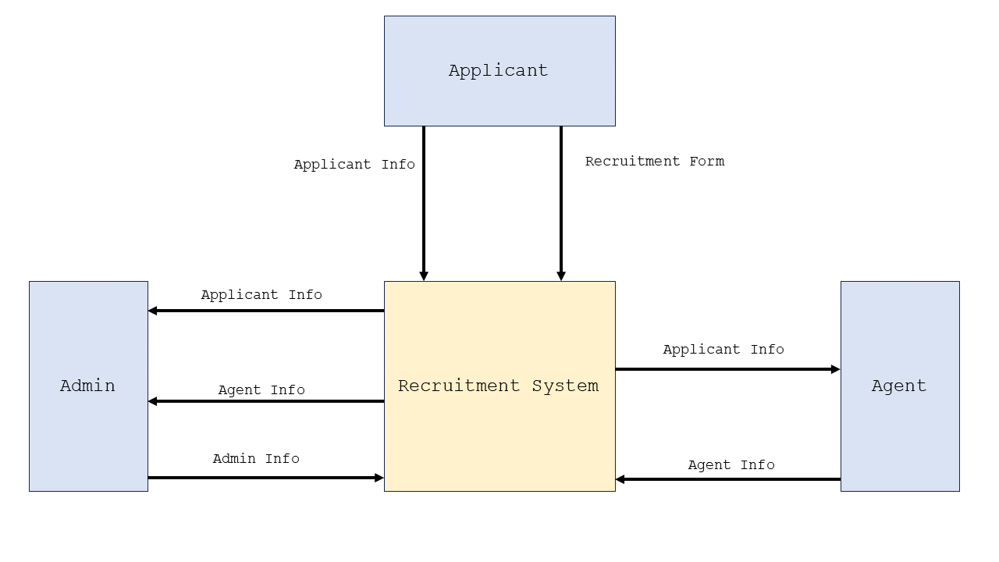This section shows the Data Flow Diagram Level 0 which is commonly known as an exploded view of the context diagram that shows the detailed process of how the project works.

**Figure 2. Data Flow Diagram Level 0**

Figure 3: DFD Level 0 illustrates the interactions and data flows between the Admin, Agents, and Applicants.

**UML Use-case Diagram**

This section introduces the use case diagram, which provides a high-level overview of functions within a system. It includes a graphic representation illustrating the relationships among key actors such as the system, admin, agent, and users. The diagram serves as a tool for researchers to understand and organize the system's functionality by showcasing how these actors interact.

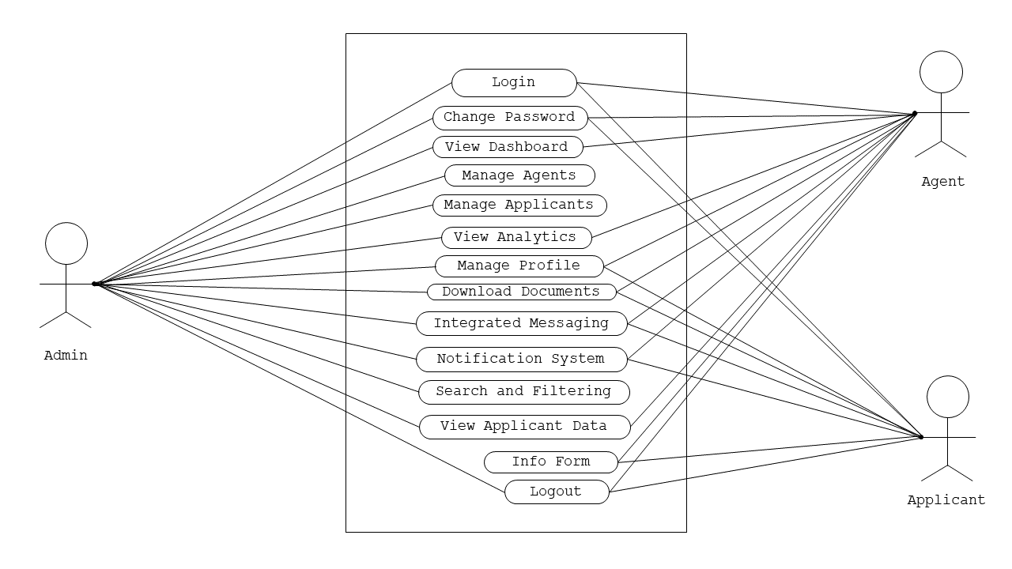

**Figure 3. UML Use-case Diagram**

Figure 3 shows the roles of the Administrator, Agent, and the Applicants to be executed in the whole process of the system.

**Sample Mock-up**

A sample mock-up is a visual representation of a website after it is built. It consists of visuals that show how the website should look and its function. It is used to refine the design, identify potential problems, and ensure that the system meets the user's needs and expectations. Below are the system users and admin interface

**Figure 4. User Interface**

**Development Method**

Agile method is chosen for this research, for the reason that it is really well-suited for developing the website for E-recruitment System. Each of which is necessary for an online hiring system to be successful and efficient. The effectiveness and efficiency of an online hiring system depend on its ability to adapt to changing needs and developing technology, which is why this strategy enables continuous improvements and adjustments. Agile's emphasis on customer input and collaboration further guarantees that the E-recruitment System will precisely match the needs and expectations of its users, which enhances the system's A diagram of a process
overall efficacy.

**Figure 5. Agile Methodology Model**

Figure 5 illustrates the researchers' utilization of Agile methodologies as frameworks for project development. This method places emphasis on breaking down large projects into smaller, easier-to-manage activities. Teams participate in all phases of the project lifecycle, from gathering requirements to design, coding, development, and testing, and the tasks are finished in short iterations. The client is presented with and given a demonstration of a working system at the end of this phase.

**Gantt Chart**

In this section, Gantt Chart is presented to show the plans and schedules of the project timeline. All the development stages up to the completion of the project were documented in this chart. This helps the researchers to know the deadlines needed to accomplish and show breakthroughs in various tasks.

|  |  |  |  |  |  |  |  |  |  |  |
| --- | --- | --- | --- | --- | --- | --- | --- | --- | --- | --- |
| **Task Name** | **Task Date** | | | | | | | | | |
| Oct | | | | Nov | | | | Dec | |
| Week 1 | Week 2 | Week 3 | Week 4 | Week 1 | Week 2 | Week 3 | Week 4 | Week 1 | Week 2 |
| **1.Planning** |  |  |  |  |  |  |  |  |  |  |
| 1.1 Conduct an interview |  |  |  |  |  |  |  |  |  |  |
| 1.2 Define project objectives |  |  |  |  |  |  |  |  |  |  |
| 1.3 Define project plan |  |  |  |  |  |  |  |  |  |  |
| 1.4 Approval of project plan |  |  |  |  |  |  |  |  |  |  |
| **2.Requirements Gathering** |  |  |  |  |  |  |  |  |  |  |
| 2.1 Data Collection |  |  |  |  |  |  |  |  |  |  |
| 2.2 Functional |  |  |  |  |  |  |  |  |  |  |
| 2.3 Non-Functional |  |  |  |  |  |  |  |  |  |  |
| **3.Design** |  |  |  |  |  |  |  |  |  |  |
| 3.1 Frontend software design |  |  |  |  |  |  |  |  |  |  |
| **4.Development** |  |  |  |  |  |  |  |  |  |  |
| 4.1 Back-end coding |  |  |  |  |  |  |  |  |  |  |
| **5.Testing** |  |  |  |  |  |  |  |  |  |  |
| 5.1 Functionality testing |  |  |  |  |  |  |  |  |  |  |
| 5.2 User interface testing |  |  |  |  |  |  |  |  |  |  |

**Table 5 Group Gantt Chart**

|  |  |  |  |  |  |  |  |  |  |  |
| --- | --- | --- | --- | --- | --- | --- | --- | --- | --- | --- |
| **Task Name** | **Task Date** | | | | | | | | | |
| Oct | | | | Nov | | | | Dec | |
| Week 1 | Week 2 | Week 3 | Week 4 | Week 1 | Week 2 | Week 3 | Week 4 | Week 1 | Week 2 |
| **1.Planning** |  |  |  |  |  |  |  |  |  |  |
| 1.1 Conduct an interview |  |  |  |  |  |  |  |  |  |  |
| 1.2 Define project objectives |  |  |  |  |  |  |  |  |  |  |
| 1.3 Define project plan |  |  |  |  |  |  |  |  |  |  |
| 1.4 Approval of project plan |  |  |  |  |  |  |  |  |  |  |
| **2.Requirements Gathering** |  |  |  |  |  |  |  |  |  |  |
| 2.1 Data Collection |  |  |  |  |  |  |  |  |  |  |
| 2.2 Functional |  |  |  |  |  |  |  |  |  |  |
| 2.3 Non-Functional |  |  |  |  |  |  |  |  |  |  |
| **3.Development** |  |  |  |  |  |  |  |  |  |  |
| 4.1 Back-end coding |  |  |  |  |  |  |  |  |  |  |
| **4.Testing** |  |  |  |  |  |  |  |  |  |  |
| 5.1 Functionality testing |  |  |  |  |  |  |  |  |  |  |
| 5.2 User interface testing |  |  |  |  |  |  |  |  |  |  |

**Table 6 Jandel Escalera Gantt Chart**

|  |  |  |  |  |  |  |  |  |  |  |
| --- | --- | --- | --- | --- | --- | --- | --- | --- | --- | --- |
| **Task Name** | **Task Date** | | | | | | | | | |
| Oct | | | | Nov | | | | Dec | |
| Week 1 | Week 2 | Week 3 | Week 4 | Week 1 | Week 2 | Week 3 | Week 4 | Week 1 | Week 2 |
| **1.Planning** |  |  |  |  |  |  |  |  |  |  |
| 1.1 Conduct an interview |  |  |  |  |  |  |  |  |  |  |
| 1.2 Define project objectives |  |  |  |  |  |  |  |  |  |  |
| 1.3 Define project plan |  |  |  |  |  |  |  |  |  |  |
| 1.4 Approval of project plan |  |  |  |  |  |  |  |  |  |  |
| **2.Requirements Gathering** |  |  |  |  |  |  |  |  |  |  |
| 2.1 Data Collection |  |  |  |  |  |  |  |  |  |  |
| 2.2 Functional |  |  |  |  |  |  |  |  |  |  |
| 2.3 Non-Functional |  |  |  |  |  |  |  |  |  |  |
| **3.Design** |  |  |  |  |  |  |  |  |  |  |
| 3.1 Frontend software design |  |  |  |  |  |  |  |  |  |  |
| **4.Testing** |  |  |  |  |  |  |  |  |  |  |
| 5.1 Functionality testing |  |  |  |  |  |  |  |  |  |  |
| 5.2 User interface testing |  |  |  |  |  |  |  |  |  |  |

**Table 7 Jef Ramos Gantt Chart**

|  |  |  |  |  |  |  |  |  |  |  |
| --- | --- | --- | --- | --- | --- | --- | --- | --- | --- | --- |
| **Task Name** | **Task Date** | | | | | | | | | |
| Oct | | | | Nov | | | | Dec | |
| Week 1 | Week 2 | Week 3 | Week 4 | Week 1 | Week 2 | Week 3 | Week 4 | Week 1 | Week 2 |
| **1.Planning** |  |  |  |  |  |  |  |  |  |  |
| 1.1 Conduct an interview |  |  |  |  |  |  |  |  |  |  |
| 1.2 Define project objectives |  |  |  |  |  |  |  |  |  |  |
| 1.3 Define project plan |  |  |  |  |  |  |  |  |  |  |
| 1.4 Approval of project plan |  |  |  |  |  |  |  |  |  |  |
| **2.Requirements Gathering** |  |  |  |  |  |  |  |  |  |  |
| 2.1 Data Collection |  |  |  |  |  |  |  |  |  |  |
| 2.2 Functional |  |  |  |  |  |  |  |  |  |  |
| 2.3 Non-Functional |  |  |  |  |  |  |  |  |  |  |
| **3.Design** |  |  |  |  |  |  |  |  |  |  |
| 3.1 Frontend software design |  |  |  |  |  |  |  |  |  |  |
| **4.Testing** |  |  |  |  |  |  |  |  |  |  |
| 5.1 Functionality testing |  |  |  |  |  |  |  |  |  |  |
| 5.2 User interface testing |  |  |  |  |  |  |  |  |  |  |

**Table 8 Lester Caibal Gantt Chart**

**Legend:** - Completed/ Done

Table 5 to 8 shows the whole process of developing E-Recruit Website. It displayed the various tasks and marks as completed oats certain date as a group, but the other three tables are for individual gantt charts. Researchers will be kept informed of the progress of the development which will help them not to miss out on steps and differentiate tasks from the amount of time took to complete them

**CHAPTER IV**

In this chapter, researcher explore into the consequential outcomes of the implemented system, unveiling the tangible results and their implications on our overarching objectives.

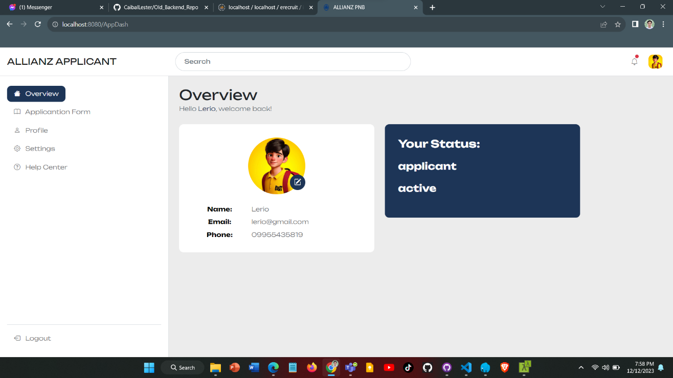

**Figure 4. Applicant Dashboard**

In this figure, you will be able to see the applicant’s profile.

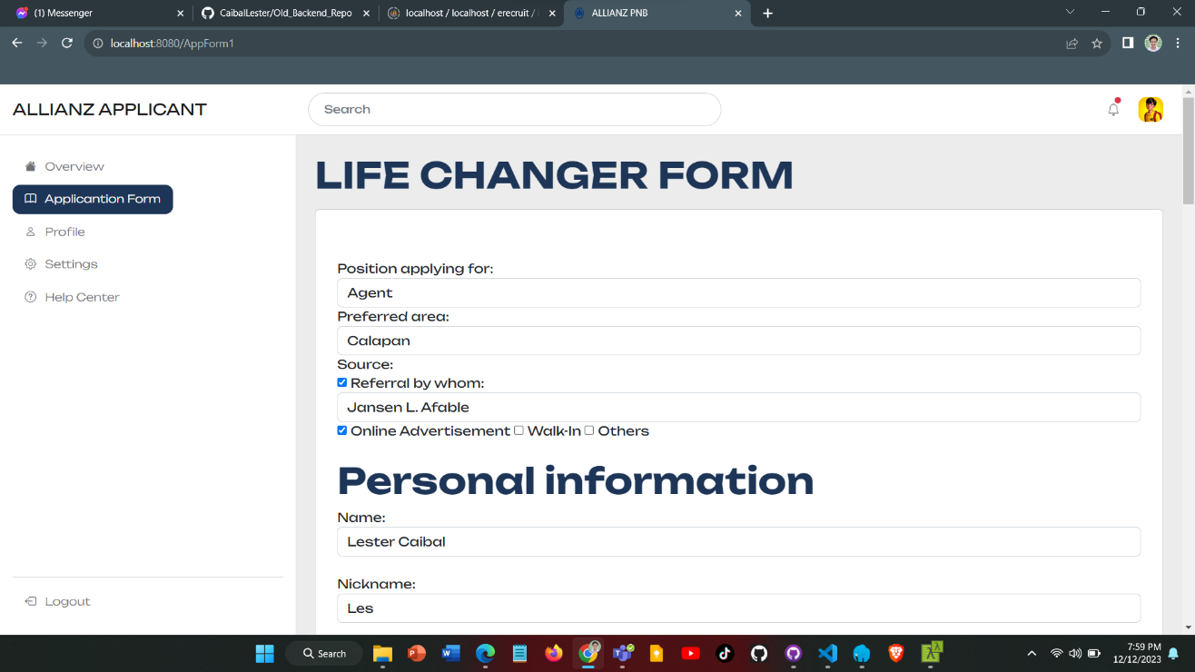

**Figure 5. Applicant Form**

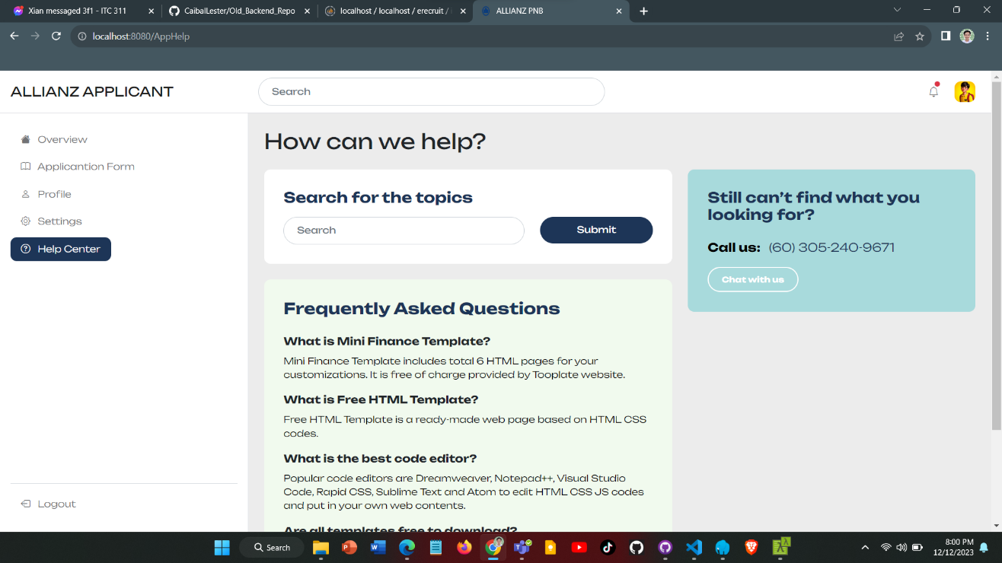 In this interface, you see here the application forms of the company and how they accept applicants.

**Figure 6. Applicant Help Center**

In this part of the system, you will be able to get help in customer assistance.

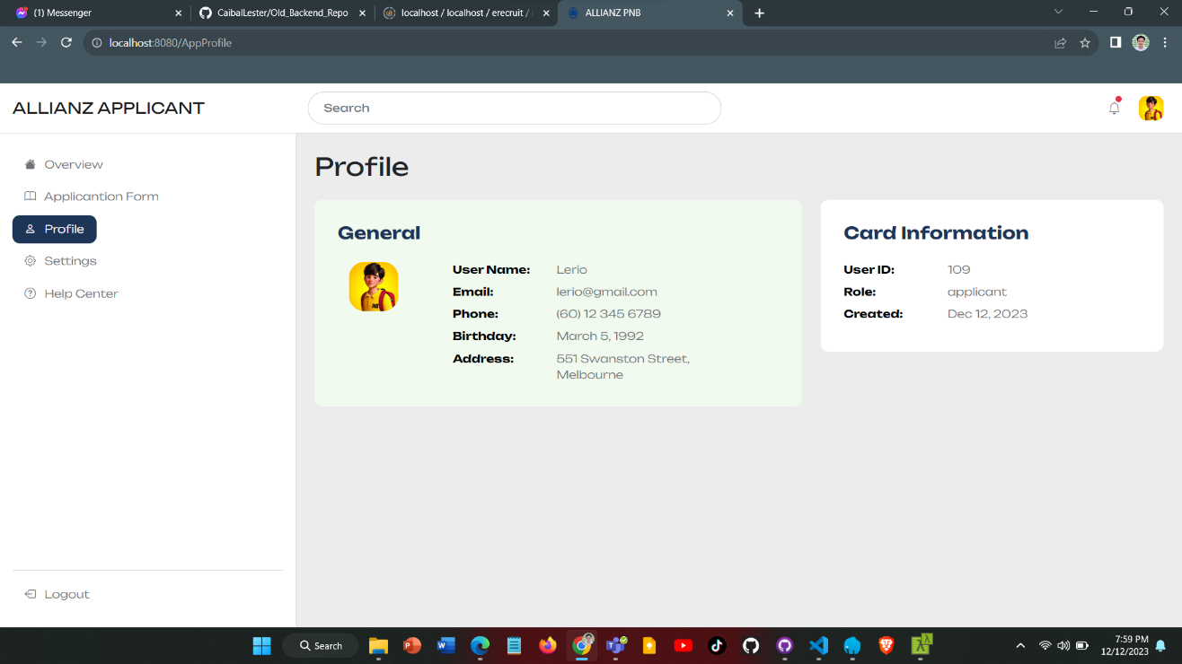

**Figure 7. Applicant Profile**

In this section of the system, you will see the applicant’s profile.

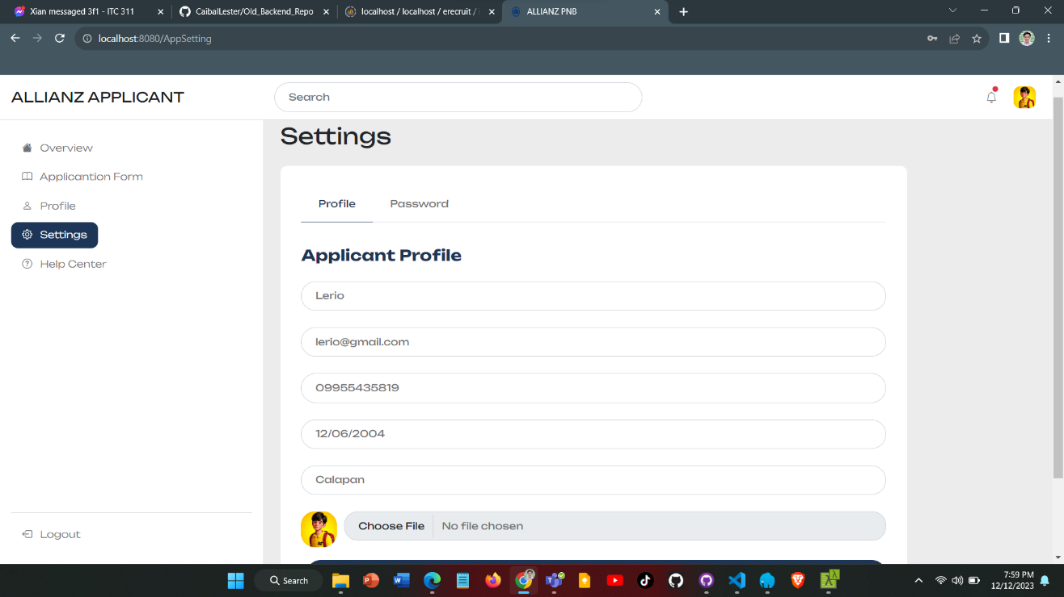

**Figure 8. Applicant Settings**

The applicants will be able to adjust their accounts and the files that they sent.

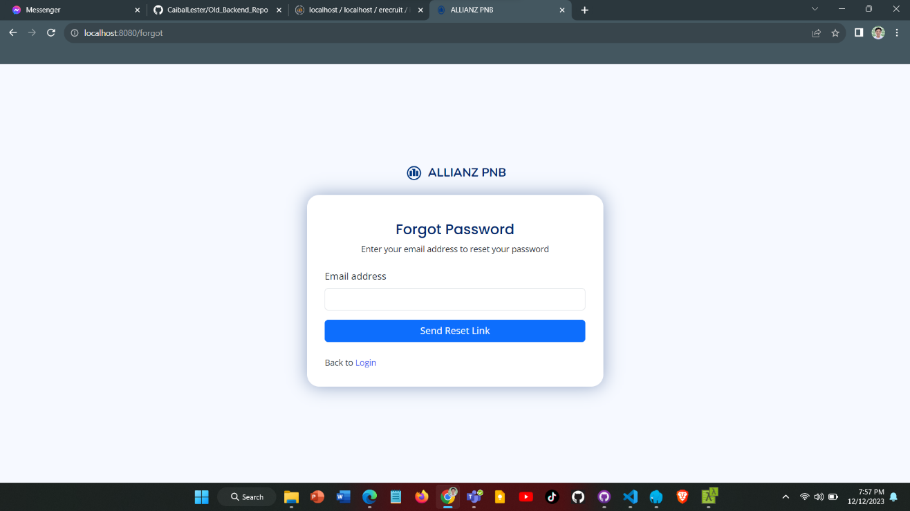

**Figure 9. Forgot Password**

In this section, the users can change their password and recover their accounts when forgotten.

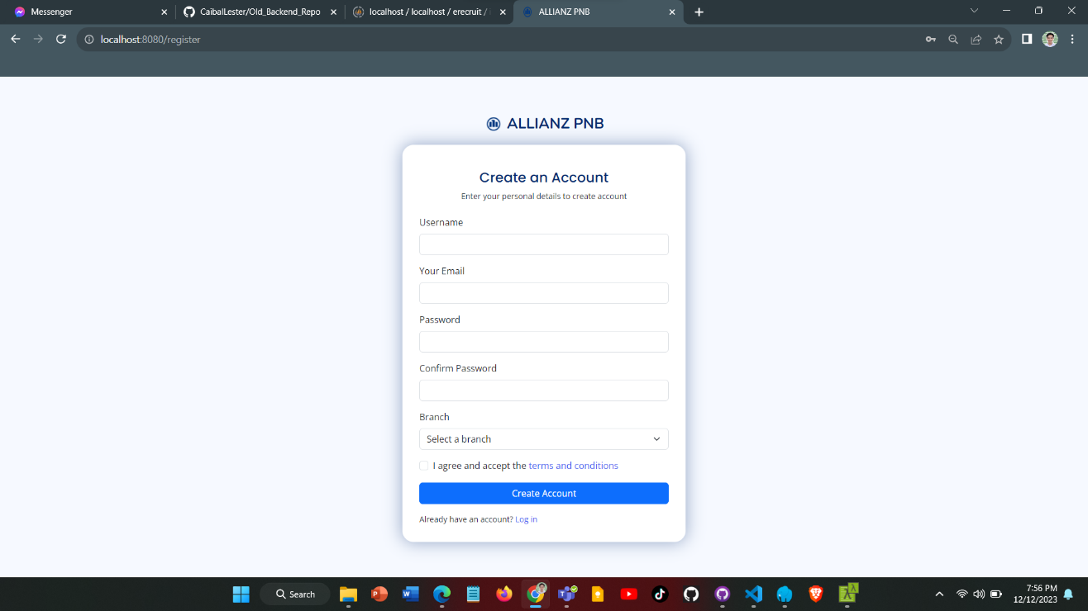

**Figure 10. Register**

New users are going to be here and will make their accounts in order to get into the website.

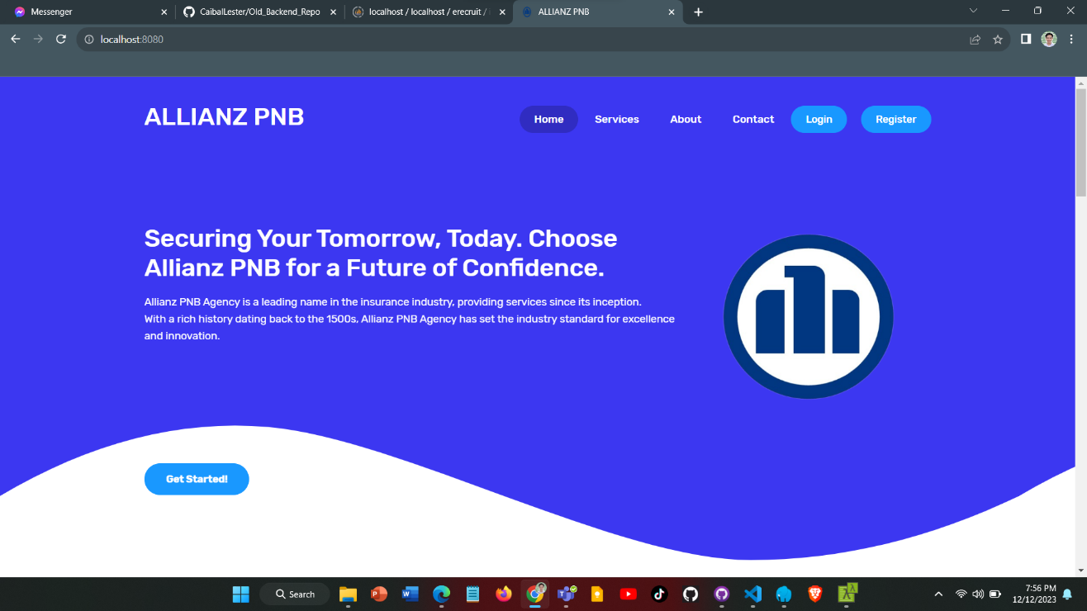

**Figure 11. Home**

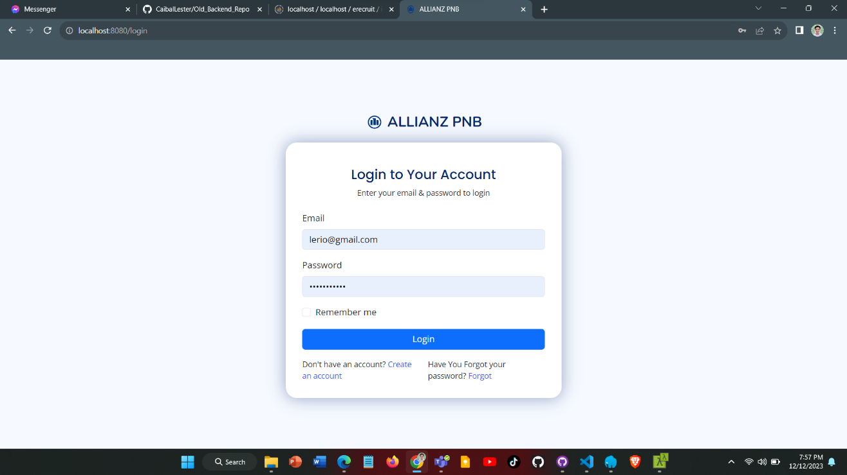 This is what the homepage of the E=Recruit website looks like.

**Figure 12. Login**

This is the login page of the website. Registered accounts can only be accessed.

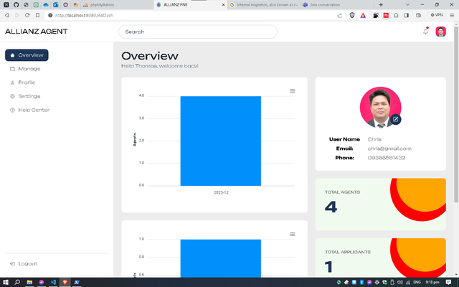

**Figure 13. Admin Dashboard**

The admin dashboard serves as a centralized control hub, monitoring, and management tools for administration.

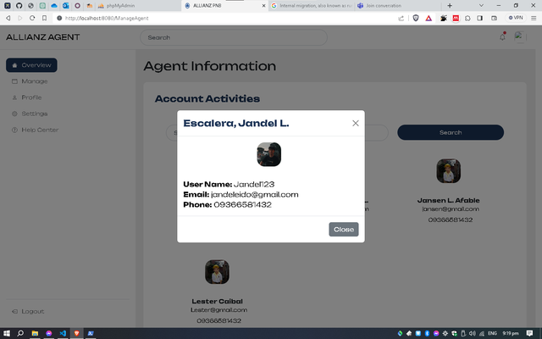

**Figure 14. Agent Management**

Agent management involves overseeing and optimizing the performance, productivity, and coordination of agents within a system to ensure efficient operations and achieve strategic goals.

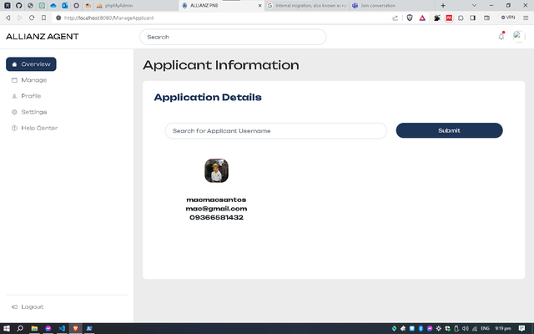

**Figure 15. Applicant Management**

Admin can see the information from the applicant so that the administrator can confirm applicant’s status.

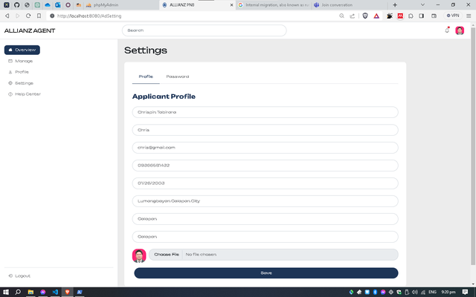

**Figure 16. Admin Setting**

Admin settings are like personalized controls in a system, letting administrators adjust things like passwords, and user permissions to fit their needs.

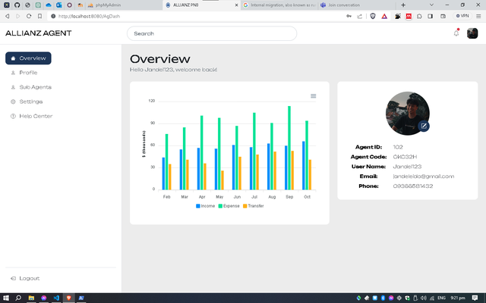

**Figure 17. Agent Dashboard**

The agent dashboard is a central hub for agents, providing a user-friendly interface to access key information, tasks, and tools, facilitating efficient workflow management.

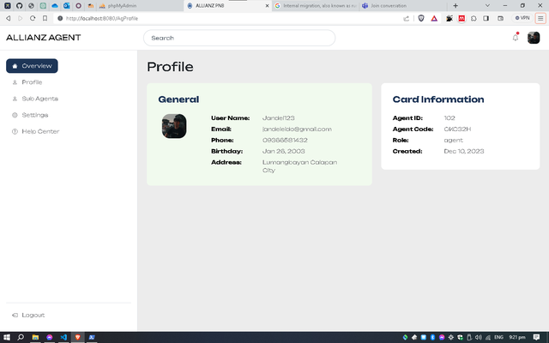

**Figure 18. Agent Profile**

Agent can view their information so that they can manage it or change it according to their needs.

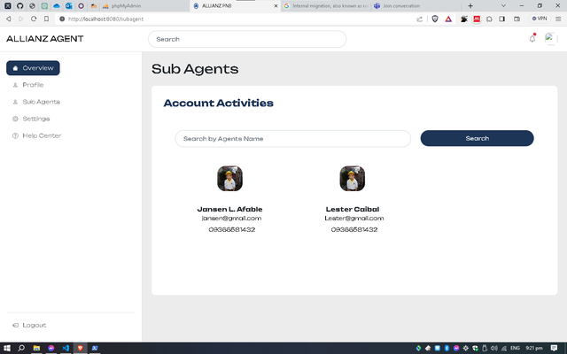

**Figure 19. Sub-Agents Management**

Sub-agents management involves overseeing and coordinating the activities of subsidiary agents within a system or organization.

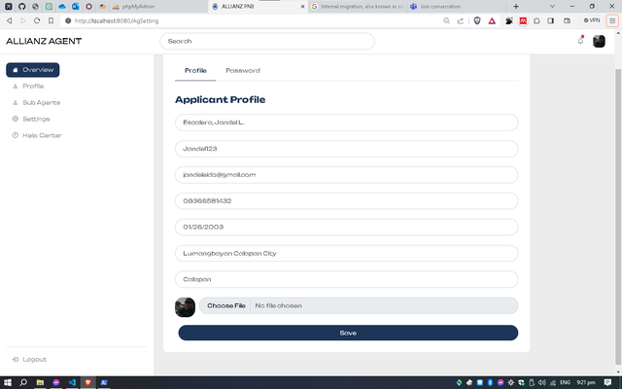

**Figure 17. Agent Setting**

Agent settings allow individual agents to customize and manage their personal information or preferences within a system, optimizing functionality to suit their needs.

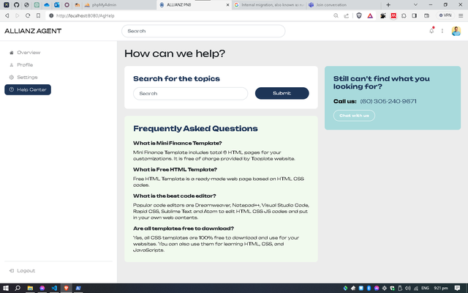

**Figure 18. Agent Help Center**

The agent help center serves as a resource hub, offering support, guidance, and information to assist agents to effectively utilizing tools and features within a system.

**Chapter V**

This Chapter concludes our exploration by synthesizing key findings, offering insightful recommendations, and reflecting on the broader implications of the study's outcomes.

**Conclusion**

The Online Recruitment System for Insurance and Investment Agents in Mindoro offers a innovative approach to modernize the hiring process for insurance and investment agents. By leveraging data analysis for informed decision-making, the system demonstrates a forward-looking strategy to attract and manage applicant effectively. The inclusion of a dedicated dashboard, secure logins, and communication facilities underscores the system's commitment to user accessibility and security. Furthermore, the emphasis on non-functional development, back-end coding, and thorough testing reflects a meticulous approach to system design and implementation. It serves as a valuable resource for professionals in the recruitment and technology fields, providing insights into the potential of online platforms and data-driven processes in talent acquisition. The system's adherence to data protection and recruitment regulations, as well as its capacity to manage candidate databases and prevent application delays, highlights its commitment to compliance and efficiency. Overall, the Online Recruitment System for Insurance and Investment Agents in Mindoro represents a significant advancement in recruitment technology, with the potential to revolutionize the hiring landscape in the region.

**Recommendations**

**Employers and Hiring Managers:** The system will benefit employers and hiring managers by streamlining the recruitment process, providing a user-friendly platform for managing applicant data, and enabling efficient communication with applicants and agents. Employers and hiring managers will have access to a database of potential candidates for future openings, facilitating a more organized and effective hiring process.

**IT Professionals and System Administrators:** IT professionals and system administrators will benefit from the project by gaining insights into the design and implementation of an online recruitment system. They can leverage the system's features and functionalities to enhance their understanding of online platforms for recruitment and contribute to the development and maintenance of similar systems in the future.

**Academic Researchers and Educators:** Academic researchers and educators in the field of human resources, technology, and business administration can benefit from the project by using it as a case study for understanding the application of emerging technology in recruitment processes. The project provides valuable insights into the development of an online recruitment system tailored to the specific needs of the insurance and investment industry, offering a practical example for academic research and educational purposes.

**Agents:** Agents should fully engage with the Online Recruitment System to optimize the recruitment process and enhance their experience. The system enables agents to manage their account details, communicate with administrators and recruits, and access performance data for interpretation and analysis. By utilizing the system's features, improve communication with applicants, and effectively manage their recruitment activities.

**User:** Users, including administrators, agents, and applicants, should actively utilize the Online Recruitment for the process and improve the overall recruitment experience. The system offers a user-friendly platform for applicants, allowing them to browse and select financial advisers, save their work, and communicate with the system administrator or assigned agents regarding their application. For administrators, the system provides tools for managing profile details, accessing performance data, and facilitating communication between all parties involved in the recruitment process. By fully engaging with the system, users can enhance the accuracy, efficiency, and inclusivity of the recruitment process.

**REFERENCES**

Edirisinghe, S. M. (2020). *Recruitment Management System*. <https://dl.ucsc.cmb.ac.lk/jspui/bitstream/123456789/4486/1/2017%20MIT%20017.pdf>

Grace, M., Ventura, G., & Bringula, R. P. (2013). *Effectiveness of Online Job Recruitment System: Evidence from the University of the East*. www.IJCSI.org

Obipi , I. O., & Kalio, N. (2018). Recruitment Management System and Employee Procurement in the Oil and Gas Sector in Nigeria. *International Journal of Human Resource Management and Research*, *8*(2), 7–18. https://doi.org/10.24247/ijhrmrapr20182

Kmail, A. B., Maree, M., Belkhatir, M., & Alhashmi, S. M. (2016). An automatic online recruitment system based on exploiting multiple semantic resources and concept-relatedness measures. *Proceedings - International Conference on Tools with Artificial Intelligence, ICTAI*, *2016*-*January*, 620–627. https://doi.org/10.1109/ICTAI.2015.95

Ramadhani, F., & Zarlis, M. (n.d.). *Analysis of e-Recruitment System Design*. https://doi.org/10.17706/ijeeee.2019.9.1.38-45

Rosoiu, O., & Popescu, C. (n.d.). *E-recruiting Platforms: Features that Influence the Efficiency of Online Recruitment Systems*. https://doi.org/10.12948/issn14531305/20.2.2016.05

Samoli, C. (2021, May 20). *How management systems drive value in business operations*. Monday.com Blog. https://monday.com/blog/project-management/management-systems/

Sehgal, V. K., Jagtiani, A., Shah, M., Sharma, A., Jaiswal, A., & Mehta, D. (2014). Job portal-A web application for geographically distributed multiple clients. *Proceedings - 1st International Conference on Artificial Intelligence, Modelling and Simulation, AIMS 2013*, 199–204. https://doi.org/10.1109/AIMS.2013.38